No. | Answer
Compound | Ionic | Covalent | Metallic
Copper |  |  | •
Oxygen (O₂) |  | •
Ammonia (NH₃) |  | •
Calcium sulfide | •
Potassium carbonate | • | •

 | Only glucose (b) and nitrogen monoxide (d) are molecules. Helium is monatomic, brass is a metal and aluminium chloride is ionic.
Molecule | F₂ | CO₂ | H₂S
Electron dot diagram |  |  | 
Bonding pairs | 1 | 4 (2 double) | 2
Non-bonding pairs | 6 | 4 | 2

Carbon has an electron configuration of 2, 4. It will react with other atoms to gain a share of another four electrons to give it eight electrons in its outermost shell. Each hydrogen atom has one electron. Carbon will therefore combine with four hydrogen atoms to gain a share of eight electrons and to form a molecule with the formula of CH₄:

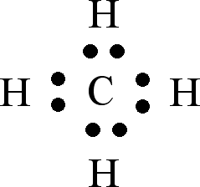
If each carbon atom only combined with three hydrogen atoms, there would only be 7 electrons in the outermost shell of the carbon atom. If the carbon combined with five hydrogen atoms there would be 9 electrons in the outermost shell. The most stable number of electrons in carbon’s outer shell is 8 electrons.
 | 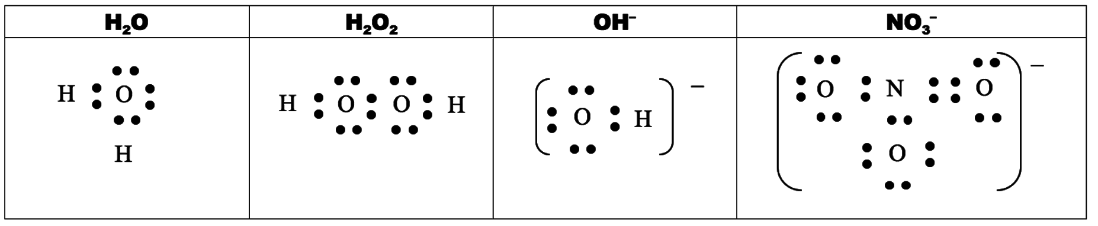

a phosphorus trichloride
b trichloromethane
c sulfur dioxide
d ethyne
a O₂, as a double bond is longer than a triple bond.
b N₂, as a triple bond is stronger than a double bond.
a 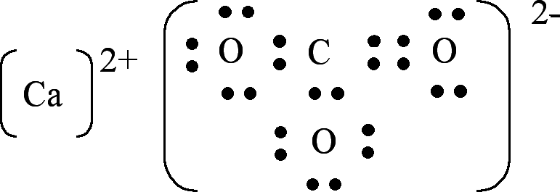

b Between the positive calcium ions and the negative carbonate ions there is ionic bonding. Between the carbon atoms and the oxygen atoms in the carbonate ions there is covalent bonding.

